Performance Testing
Date | 29 September 2026
Team ID | SWTID-2026-1410
Project Name | Streamlining IT Procurement: Automating Standard Laptop Orders With Flow Designer
Maximum Marks | 5 Marks
Performance Testing
Performance testing evaluates how your system behaves under expected and peak load conditions. Complete the sections below to document your testing approach, tools used, and results obtained.
Step 1: Testing Overview
Field | Details
Testing Tool Used | Manual test through the ServiceNow Service Catalog; timing taken from the request and catalog task timestamps (no load-testing tool such as JMeter was used)
Type of Testing | Single-user response-time test (order to fulfillment task creation)
Target Module / API | Standard Laptop catalog item and the Flow Designer flow "Standard laptop tasks" (Service Catalog trigger and Create Catalog Task action)
Test Environment | Cloud: ServiceNow Personal Developer Instance (dev277579)
Test Date | 28 September 2026
Step 2: Test Scenarios
S.No | Test Scenario / Description | No. of Virtual Users | Duration (sec) | Expected Outcome
1 | Order the Standard Laptop (no optional software) from Service Catalog > Hardware > Standard Laptop | 1 | Not timed | Request REQ and item RITM created; confirmation with request number shown
2 | Flow "Standard laptop tasks" creates the catalog task after the order | 1 | 82 (approx.) | Catalog task assigned to the Hardware group created within 2 minutes
3 | Several employees order laptops at the same time | Not performed | - | Planned for future testing
4 | Peak load: many orders in a short time | Not performed | - | Planned for future testing
Step 3: Performance Test Results
S.No | Metric | Target Value | Actual Value | Status (Pass / Fail) | Remarks
1 | Response Time (Avg): order to task creation | < 2 minutes | 82 seconds (1 order) | Pass | Order placed 23:30:49, task created 23:32:11
2 | Response Time (Max): order to task creation | < 5 minutes | 82 seconds (1 order) | Pass | Only one order was tested
3 | Throughput (Req/sec) | - | Not measured | N/A | No load tool used
4 | Error Rate | < 1% | 0% (0 errors in 1 order) | Pass | REQ, RITM and SCTASK all created
5 | CPU Utilization | < 80% | Not measured | N/A | Not visible on a hosted developer instance
6 | Memory Utilization | < 80% | Not measured | N/A | Not visible on a hosted developer instance
Step 4: Observations & Analysis
Key Findings:
A test order for the Standard Laptop (REQ0010001) was placed at 23:30:49 and the flow created the catalog task SCTASK0010001 at 23:32:11, about 82 seconds later. The task was assigned to the Hardware group with Approval set to Approved, and no errors occurred.
Bottlenecks Identified:
No bottleneck was found in this single-order test. The roughly 82 second gap is the time the platform took to start the flow after the order. Load with many users, CPU and memory could not be measured on the hosted developer instance.
Optimization Steps Taken:
None were needed. The flow was kept simple, with one trigger and one action, to keep processing quick. A load test with several concurrent orders is planned as future work.
Step 5: Screenshots / Evidence
Screenshots of the test order and its results (order confirmation, request record and the catalog task created by the flow):
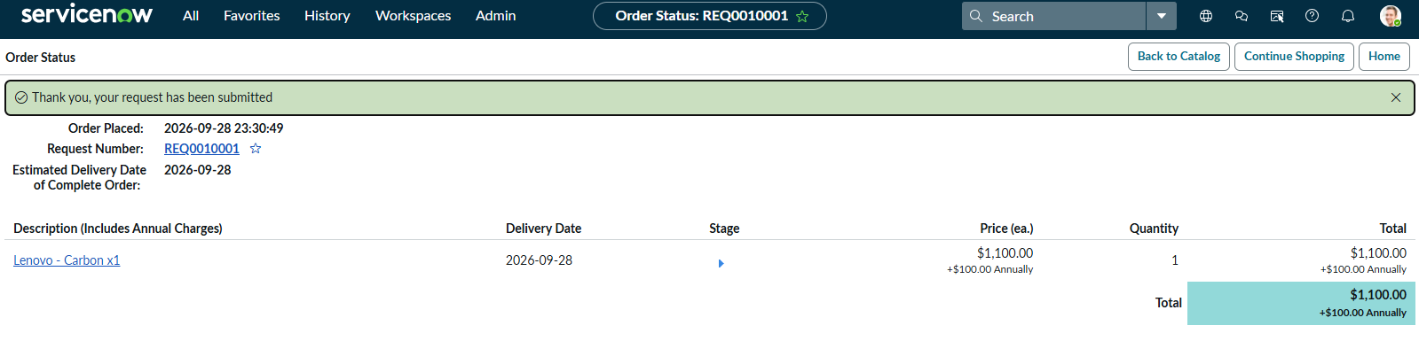
Screenshot 1: Order placed at 23:30:49, request number REQ0010001
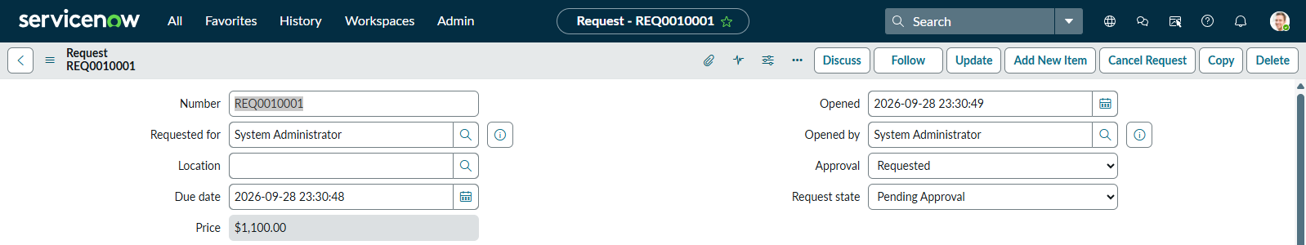
Screenshot 2: Request REQ0010001 opened at 23:30:49
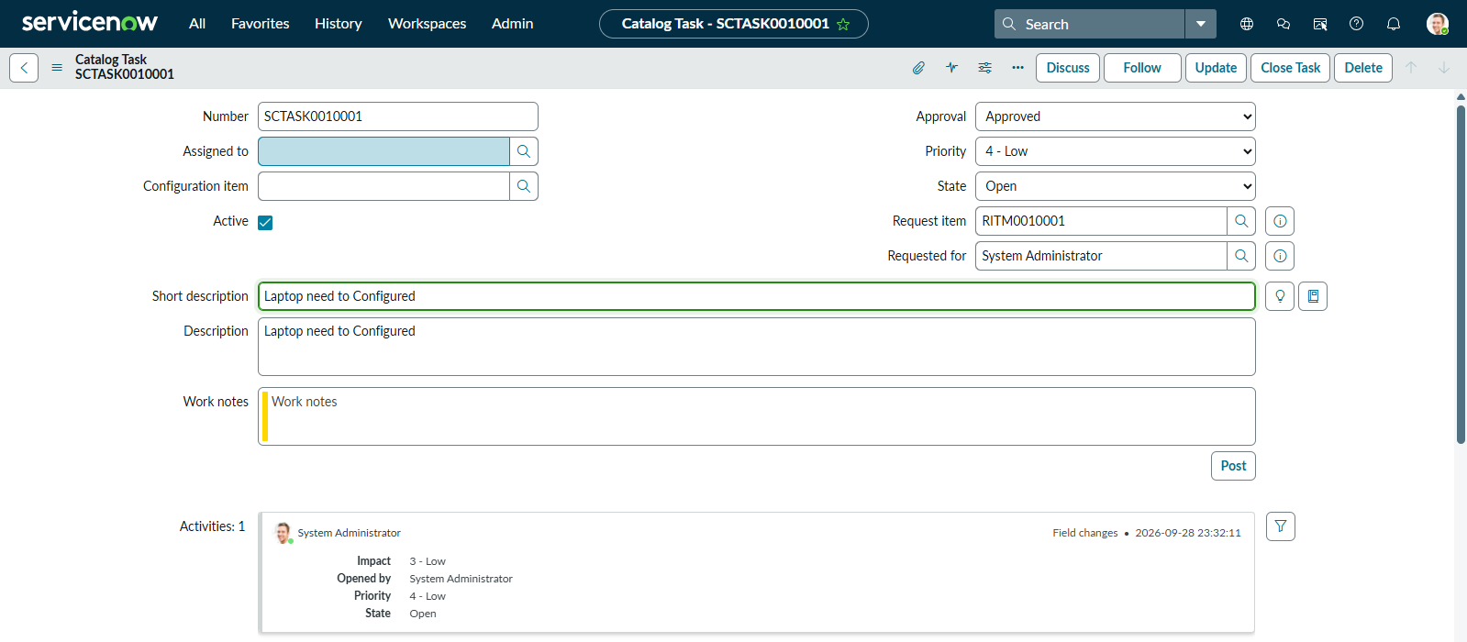
Screenshot 3: Catalog task SCTASK0010001 created by the flow at 23:32:11

